2017 Girls Soccer Apparel Item

See Order Form For Size and Color Options

WOMENS ¼ zip  Item #: 63985 Catalog Page #: 481  100% sublimated polyester  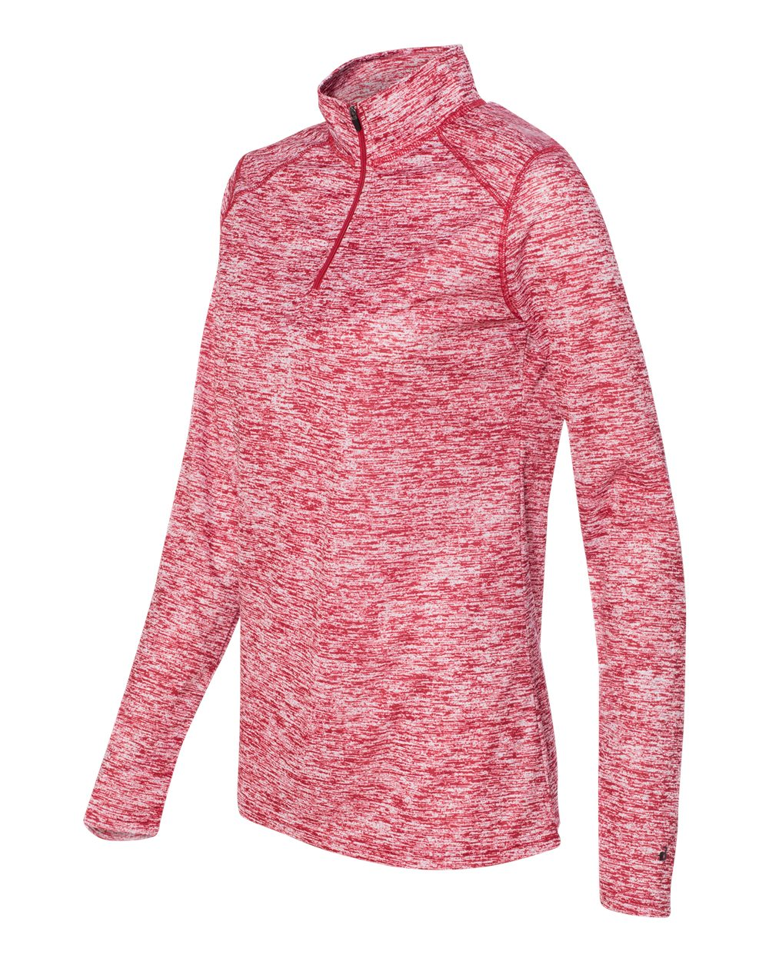  Cost~$26.50 | MENS ¼ zip  Item #: 85428 Catalog Page #: 341  80/20 ringspun cotton/polyester  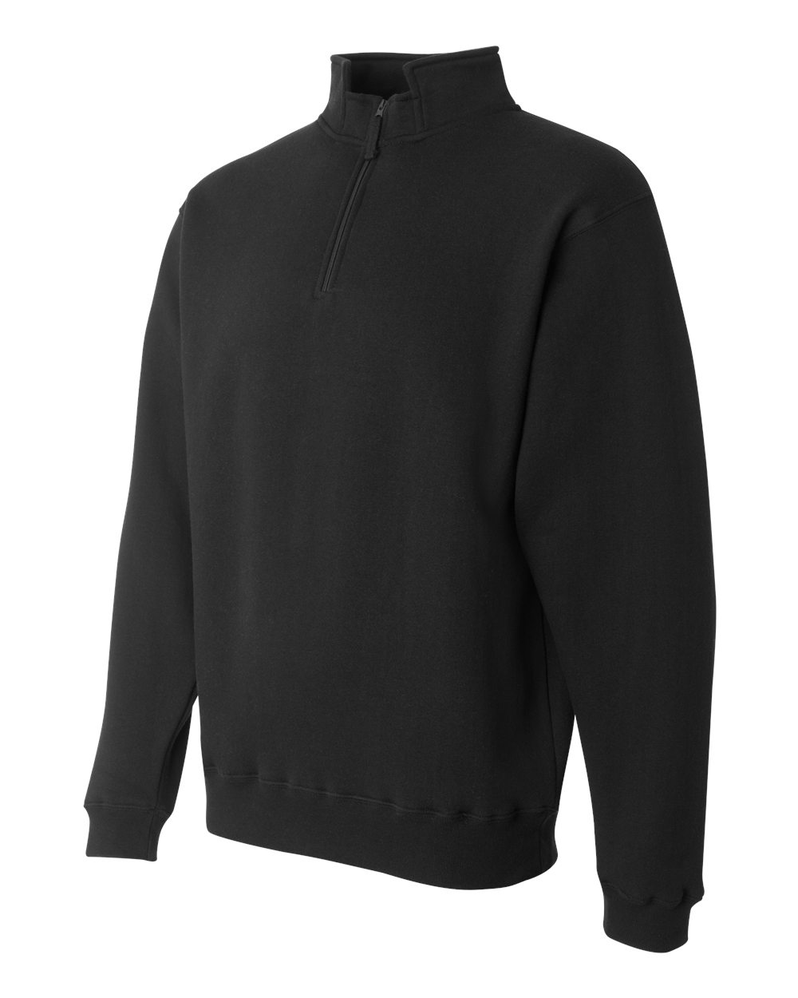  Cost~$30.00
Sweatpants  Item #: 76185 Catalog Page #:0  * cotton/polyester  * Multi-needle covered elastic waistband with inside drawcord  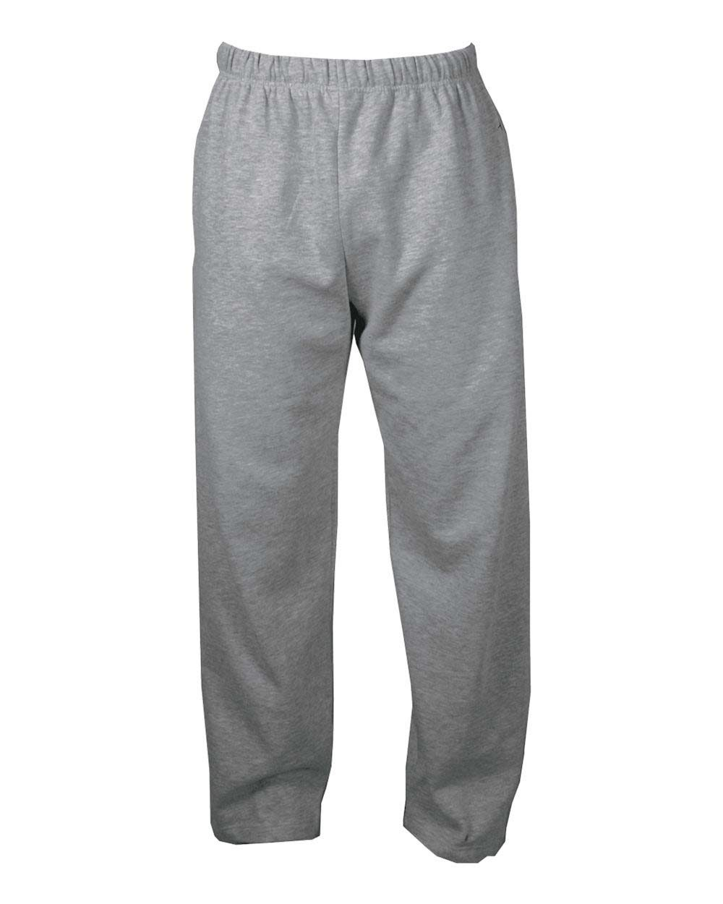  * Two side seam pockets  * Double-needle bottom hem  Cost~$20.00 | Short Sleeve T-Shirt  Item #: 06560 Catalog Page #: 255  pre-shrunk 50/50 cotton/polyester  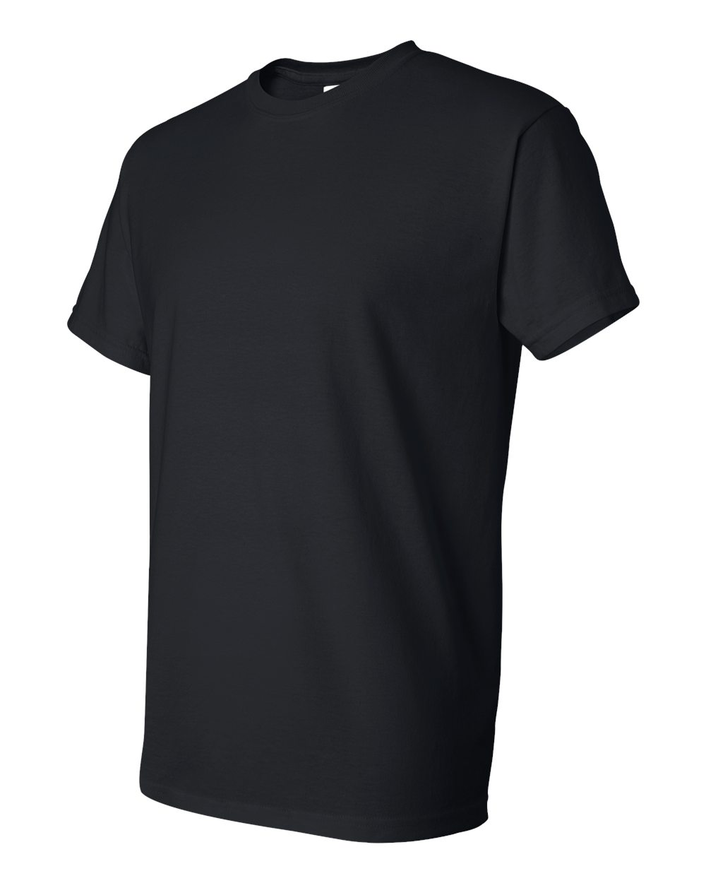  Cost~$10.00
Long Sleeve T-Shirt  Item #: 07660 Catalog Page #: 255  pre-shrunk 50/50 cotton/polyester  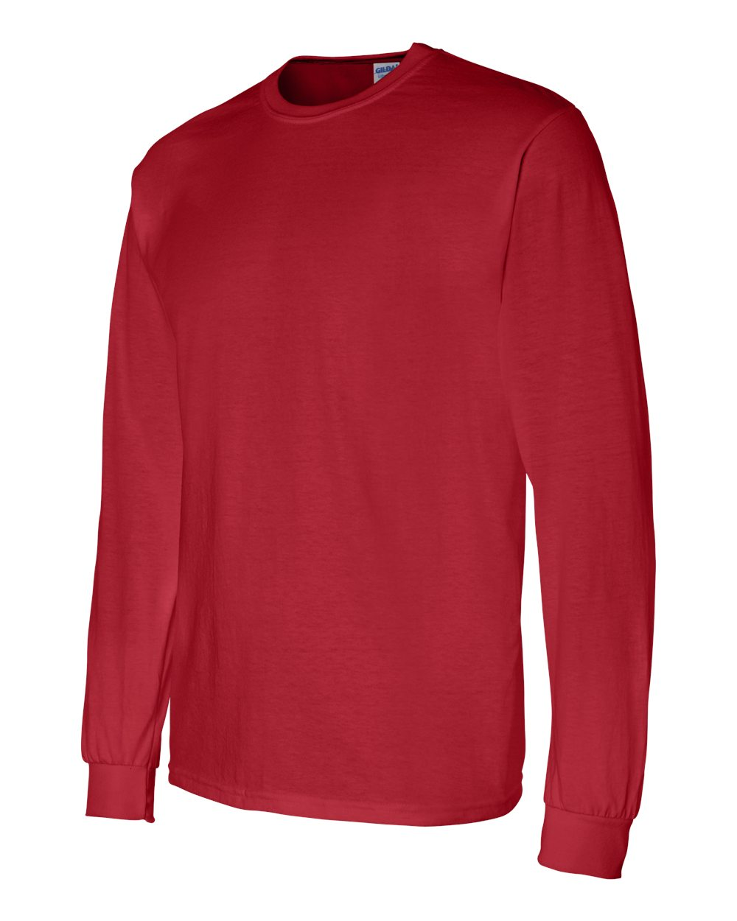  Cost~$14.00 | Short Sleeve Tie-Dye T-Shirt  Item #: 06414 Catalog Page #: 297  pre-shrunk 100% cotton  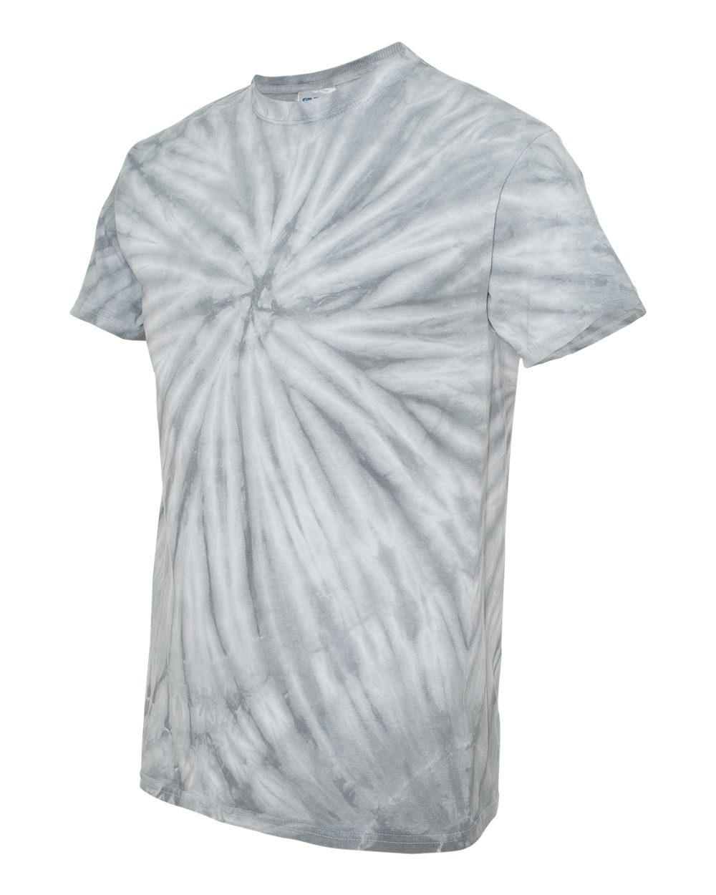  Cost~$13.00
Long Sleeve Tie-Dye T-Shirt  Item #: 83014 Catalog Page #: 297  pre-shrunk 100% cotton  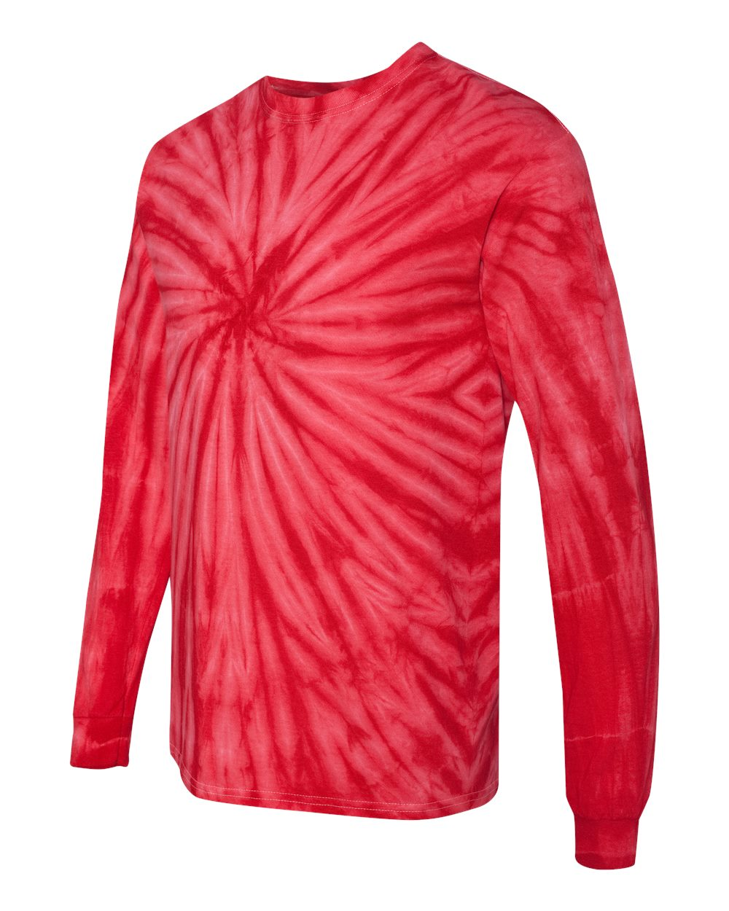  Cost~$17.00 | Crew Neck Sweatshirt  Item #: 21260 Catalog Page #: 394  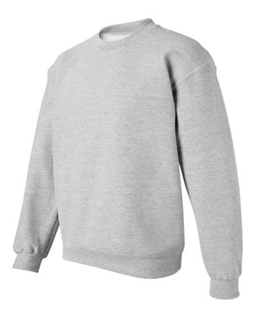  50/50 cotton/polyester  Cost~$20.00
Hoodie Sweatshirt  Item #: 22860 Catalog Page #: 394  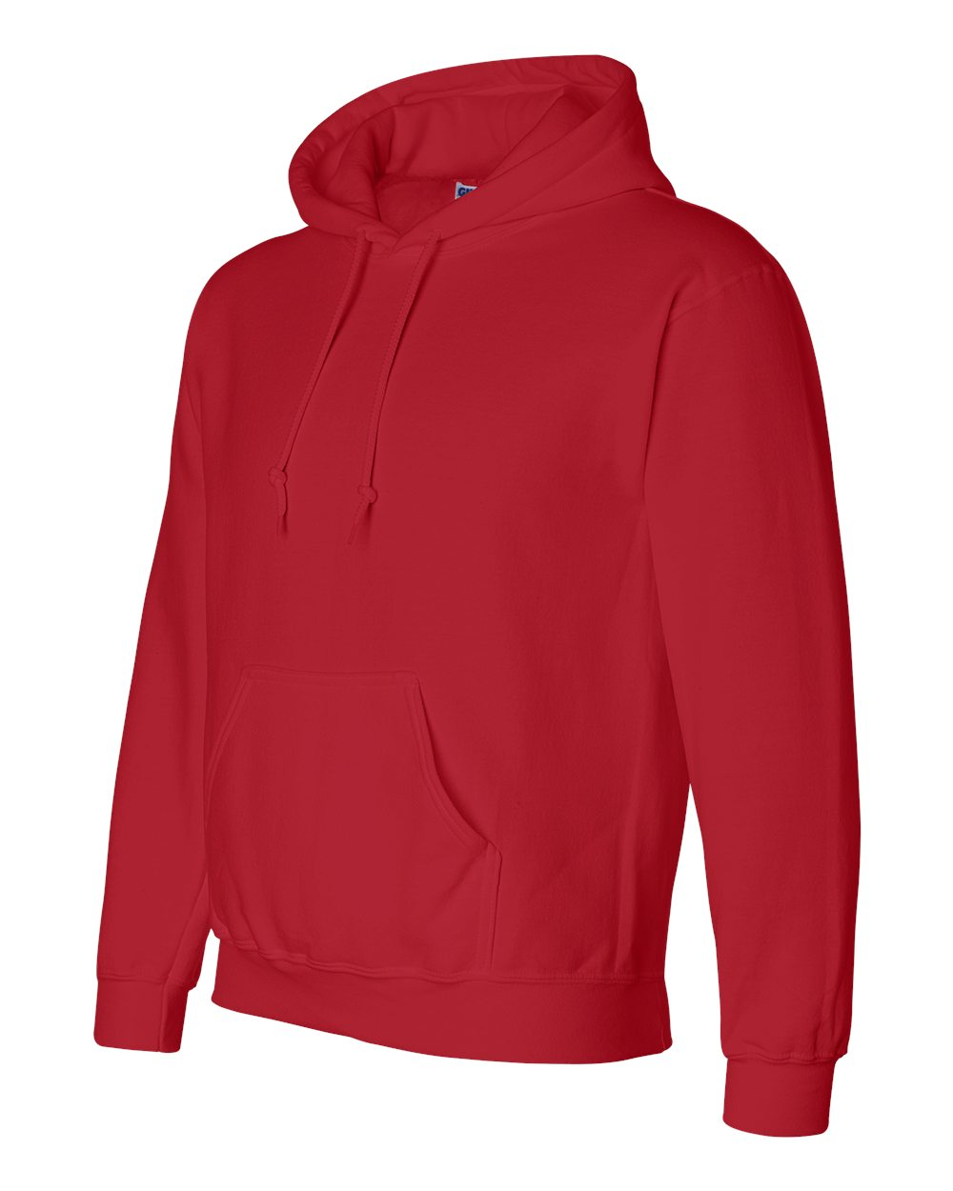  50/50 cotton/polyester  Cost~$24.00 | Color Block Hoodie  Item #: 84985 Catalog Page #: 388  100% Polyester moisture management fleece fabric  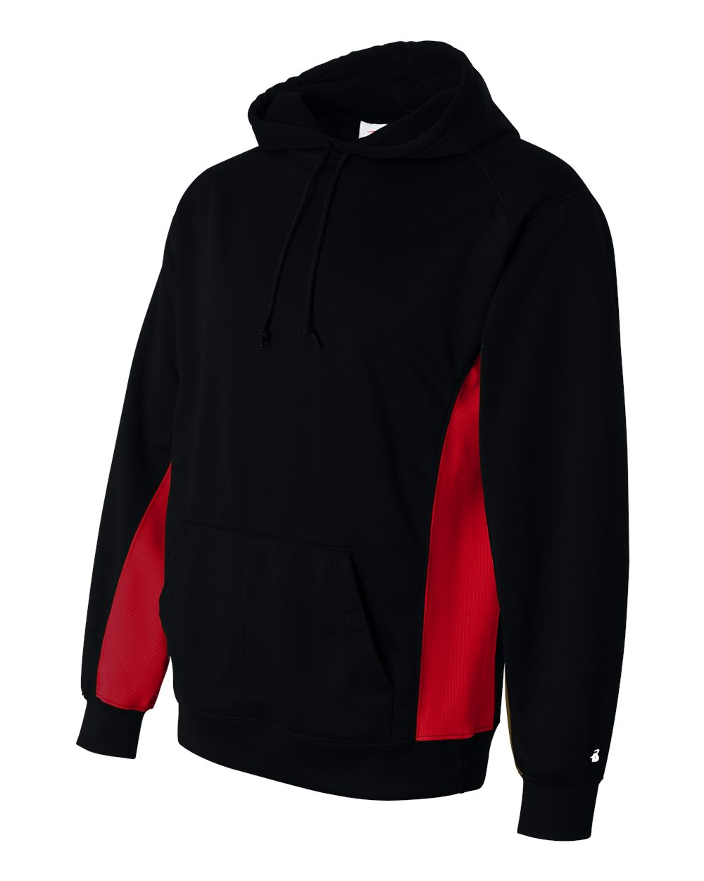  Cost~$34.00
Baseball Caps

tem #: 28295 Catalog Page #: 618
100% bio-washed chino twill

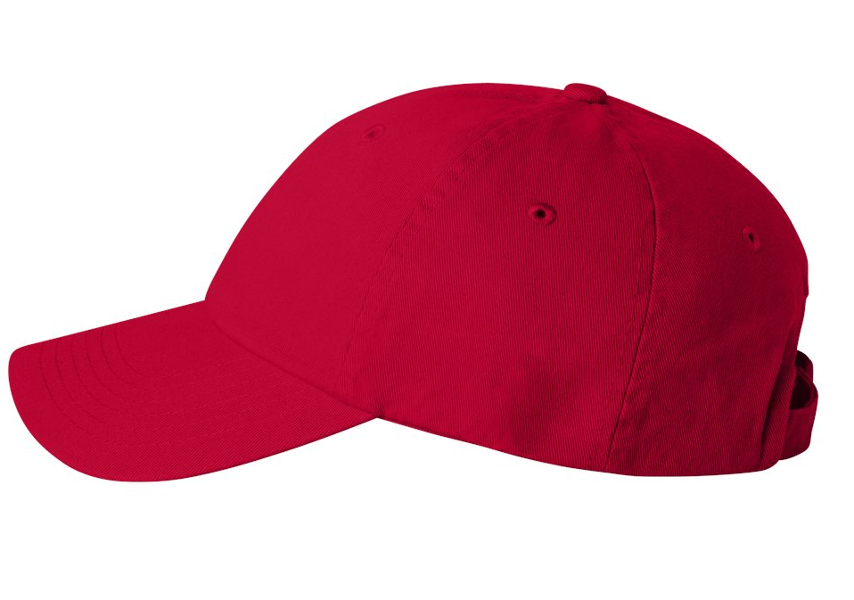
Cost~$15.00

